Pipes Demo
1- Create project demo

>> ng new pipes-demo

2- crate component

>> ng g component pipes-demo-component

- Setup Code in TS
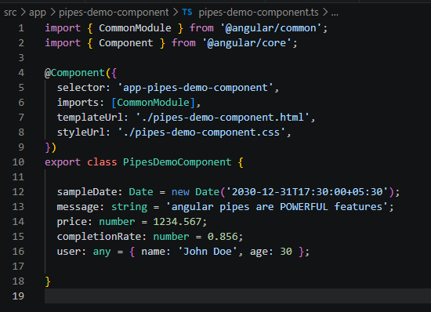

Must import: CommonModule

Example:
<!-- Date Pipe -->
<section>
<h2>Date Pipe</h2>
<p>Raw Date: {{sampleDate}}</p>
<p>Default formatted: {{sampleDate | date}}</p>
<p>Short format: {{sampleDate | date: 'short' }}</p>
<p>Medium format: {{sampleDate | date: 'medium' }}</p>
<p>Long format: {{sampleDate | date: 'long' }}</p>
<p>Full format: {{sampleDate | date: 'full' }}</p>

<p>Short date: {{sampleDate | date: 'shortDate' }}</p>
<p>Medium date: {{sampleDate | date: 'mediumDate' }}</p>
<p>Long date: {{sampleDate | date: 'longDate' }}</p>
<p>Full date: {{sampleDate | date: 'fullDate' }}</p>

<p>Short time: {{sampleDate | date: 'shortTime' }}</p>
<p>Medium time: {{sampleDate | date: 'mediumTime' }}</p>

<p>Custom format dd/MM/yyyy: {{sampleDate | date: 'dd/MM/yyyy' }}</p>
<p>Custom format EEEE, MMM d, yyyy: {{sampleDate | date: 'EEEE, MMM d, yyyy' }}</p>
<p>Custom format hh:mm:ss a: {{sampleDate | date: 'hh:mm:ss a' }}</p>
</section>

Result:
